REPORT ON INDUSTRIAL VISIT

VENUE : University of Horticulture Science, Bagalkot

DATE : 1/7/2024

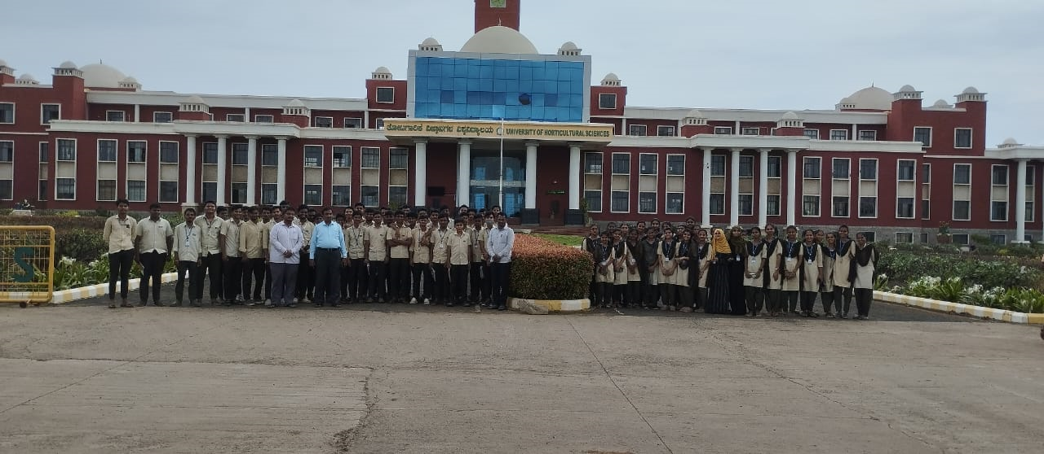

University of Horticulture Science, Bagalkot is a public university dedicated to the study and research of Horticultural Sciences established by the Government of Karnataka at Bagalkot district.

Due to rising importance of Horticulture, the University of Horticultural Sciences, Bagalkot was established by the Government of Karnataka

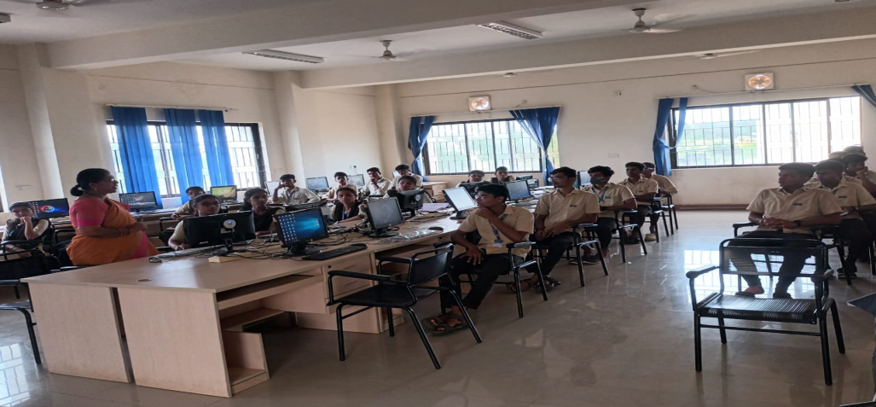 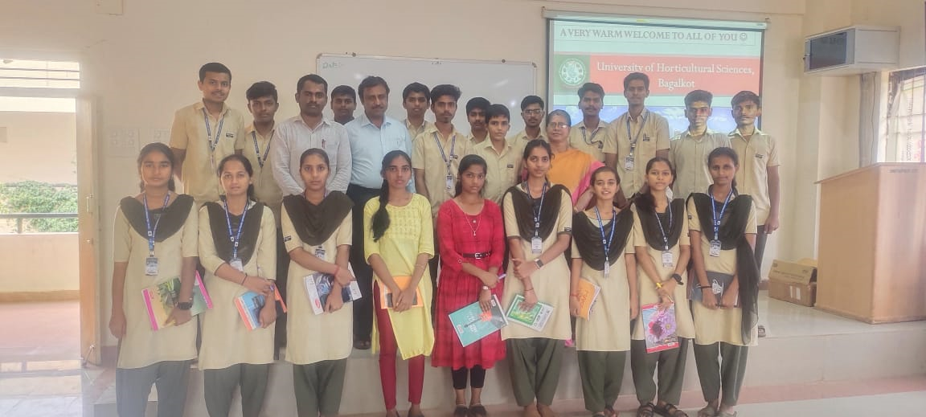

NComputing is a deskstop virtualization company that manufactures Hardware and software to create virtual deskstops which are enable multiple users to simultaneously share single operating system instance, In NComputing Monitor are using without CPU it is main Advantage.

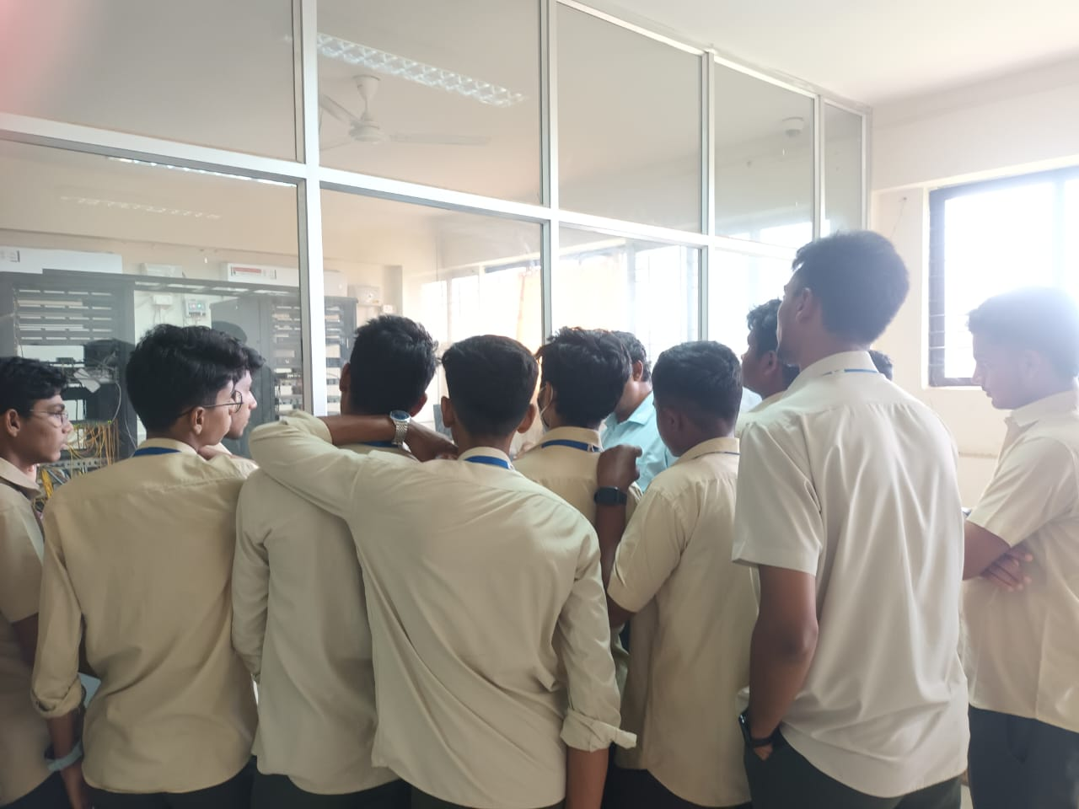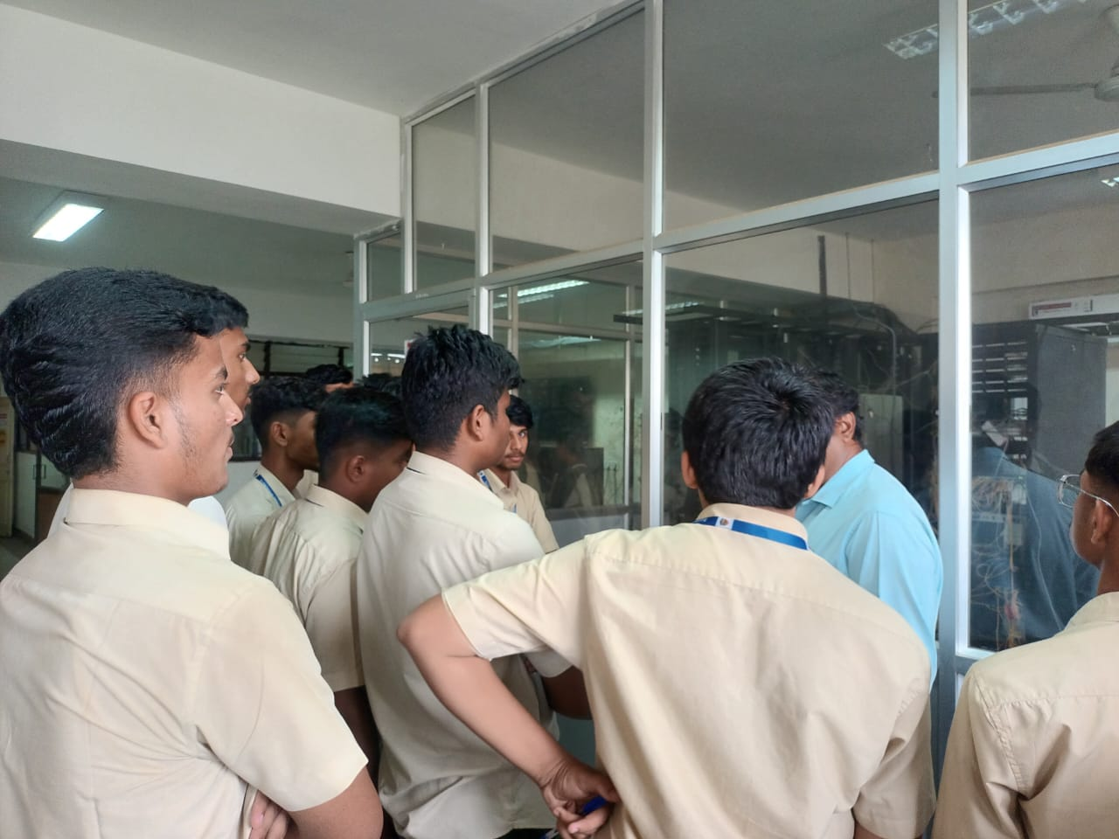

Server Rack are computer servers designed to be mounted within server rack Rack server are typically used in data center and other enterprise-level computing environment, and they are designed to be highly Scalable ,reliable, and efficient.